

**COMPUTER SCIENCE SCHOOL**

**Web-based system for technological control of construction materials and soil survey**

**Project Report**

**Information System Analysis and Modeling**

**420-AS2-AS**

**Teacher: Nariman Mansour**

**FZ programming and analyst company**

**Francieli Pinzon – 1831816**

**Zun Wang – 1835103**

**April 15, 2019**

Table of Contents

1 Introduction 3

2 General context 4

3 The goals of the web-system 6

4 Feasibility study 6

4.1 End users of the system 6

4.2 Functional requirements 7

4.3 Some functional requirements that can be added in the future 7

4.4 Nonfunctional requirements: 7

4.5 Analysis by P.I.E.C.E.S 8

4.5.1 Performance 8

4.5.2 Information and data operating 8

4.5.3 Economics 9

4.5.4 Control and Security 9

4.5.5 Efficiency 10

4.5.6 Services 10

4.6 Operational and Cultural study 10

4.7 Cost analysis for built this web-system 11

4.8 Benefit analysis 11

4.9 FZ Benefit for built the system 12

4.10 Cost benefit analysis 13

4.11 Project schedule estimation use waterfall modeling 14

5 Project Analysis Part 15

5.1 Use case analysis: three major functions 15

5.1.1 First use case of analysis 16

5.1.2 Second use case of analysis 17

5.1.3 Third use case of analysis 18

6 ERD or Class diagram 19

7 UML diagrams: use case 21

8 Web Template Demonstration 21

8.1 First demonstration 22

8.2 Second demonstration 26

# Introduction

This report refers to the Information System Analysis and Modeling project, whose objective is to create a web-based system for technological control of construction materials and soil survey.

This document includes the feasibility study, the analysis phase, and the system’s design, with the aim of apply the concepts learned in class and practice applying agile planning methods.

# General context

Using the fact that the team is made up of civil engineers, we opted for the elaboration of a system that meets the needs of this area, specifically in the sector of qualitative analysis of materials.

In civil engineering, the technological control of building materials and soil analysis represents an important sector.

The soil analysis is done even before starting a construction project so that the loads that need to be supported are determined and the types of foundations are defined.

The technological control is mainly used to verify the resistance of the materials applied in loco, as for example asphalt and concrete, that only reach the expected resistance after a few days.

In this case, when applying these materials, samples are taken to the laboratory and subjected to resistance and quality tests.

All constructions applying these materials must carry out qualitative tests in accordance with established international standards.

In this way, a system that facilitates the contracting of this type of services is an excellent business opportunity.

The system allows the client searching the service, registering an account, booking an appointment, paying the fees and following the service status.

The following images show the collection of soil, concrete and asphalt for analysis.

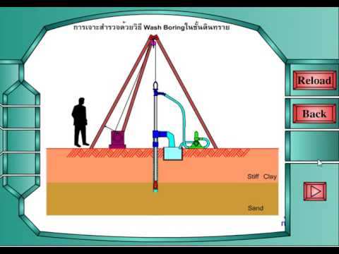

Picture 1 - Soil samples are collected from great depths

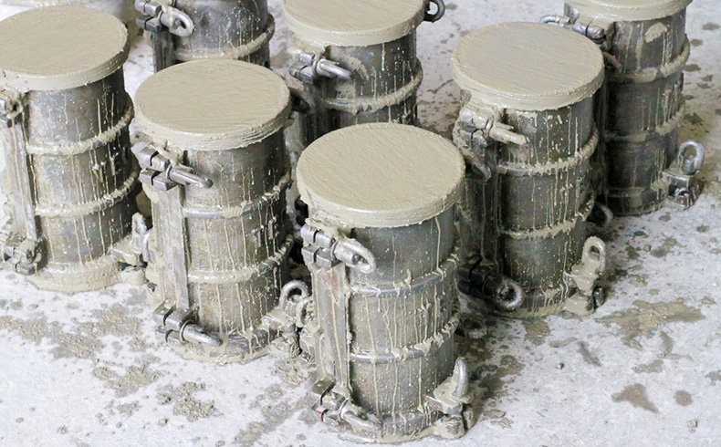

Picture 2 - Concrete samples

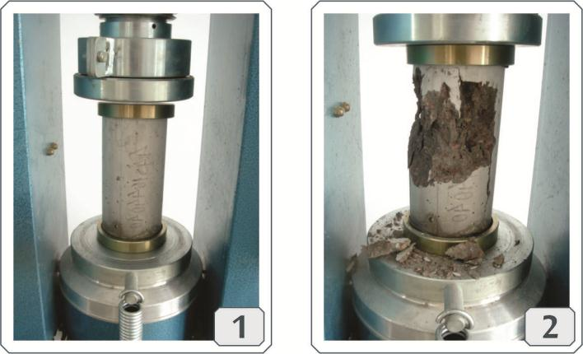

Picture 3 - disruption of samples after the time required to achieve the expected strength



Picture 4 - Asphalt samples

# The goals of the web-system

This is a business web-system, build for a company of Construction Engineering Material Testing Laboratory – CEMTL that provides services on quality inspection of construction materials.

As the first customer, the CEMTL company was used as a model for analysis of the current situation and proposition of improvements.

Having a mission to be known as the best building materials testing and engineering company in Canada, its first site uses a simple structure to present the company's culture and projects. For the needs of the current market, this site is not enough to increase the business, since it does not allow the creation of a user account, not even the hiring and payment of services and the subsequent collection of results. In addition, the download and upload speed is low and not secure.

In this field, the web site grants a relationship of contact, communication, and interaction between the company and its customers. Whit this system, the company can improve your professional services offer and the customers can use these services in a convenient way.

# Feasibility study

## End users of the system

1. The employees of the laboratory (for example the engineer who issues his analysis opinion);
2. The Construction company who want to use the services that CEMTL provide (if a construction company is building a condo, and it want to test the quality or the level of the material that is used, or it want to realize a construction quality control.
3. The government (for example, when it is necessary to build a Bridge across the river or renovate the pavement of streets and roads, it is mandatory to do the control analysis of the material).
4. The person who want to build or repair his house or other building and wants to use the service to test the construction materials (for example, somebody who wants to renew the roof of his house using asphalt roof and needs to know how to evaluate and management the process.

## Functional requirements

1. To register 4 different types of user accounts:

* employee account, account id starting by number 0;
* customer VIP account, starting by number 1;
* company account, starting by number 2;
* personal account starting by number 3.

1. Reservation appointment or book one of the service listed at the web site.
2. Filling the application service form online;
3. Online payment for the fee of the reserved service;
4. Upload some large size files, like videos, pictures and documents;
5. Online check the status or the steps of process of the material testing;
6. Download the final report made by the testing engineer;

## Some functional requirements that can be added in the future

1. The web visitor can communicate with customer service consultants online real-time;
2. The engineer provides the service for the remote meeting and technical support;
3. Company recruitment information for CEMTL to hire engineers when they need to expand new business;
4. Information about possible new branches of CEMTL.

## Nonfunctional requirements:

1. The web site can be visited by web browser, smart phone, tablet or another handheld device;
2. Can be display in two languages by choose: English or French;
3. The payment can use Canada dollar or Us dollar;
4. Can accept Multiple payment methods: credit card, us credit card, check, debit card, Bank Transfer;
5. When in the web site, the user can see the introduction of CEMTL, some big project details of accomplished projects.

## Analysis by P.I.E.C.E.S

### Performance

Use some Techniques of Website Speed Optimization:

* Use a better host server to keep our website
* Minimize the number of JavaScript and CSS files
* Use a Content Delivery Network (CDN)
* Optimize the size of images on your website
* Reduce the number of plugins
* Database optimization in CMS
* Reduce the use of web fonts

Such techniques will be used to make website performance faster and more efficient, as well as maintaining high download and upload speed. It’s estimated that the system has 3 seconds maximum response time for predefined request, and 7 seconds maximum for other requests.

In terms of system stability, other techniques can be applied, such as:

* Proper Server Monitoring,
* Test System Restoration Procedures
* Implement Corporate Collaboration Tools
* Use Big Data Analytics to Predict Outages

### Information and data operating

When users enter information or data, the system can analyze such data and guide them to enter the correct data, for example: when entering the date or phone number, they can only enter them in the correct format. The system can also provide a lot of tips to help correct input of information and avoid some human error or other errors.

For outbound information, the use of links allows you to provide more data to choose from users, who may choose to see only the information they need. For example, when users wish to search for a service, they will see the list that presents the introduction of each service, being able to select and access the chosen link correctly from the beginning of the user experience.

We believe that the data stored is the most important thing, so our team of database technicians will perform regular maintenance and technical support, and often check the data center stability.

Considering the basic information of the system, such as contact area, company history, and service detail, it is important to point out that the system will have the most relevant information described with the minimum number of words possible. The succinct way of describing the services helps the end user in their decision making.

### Economics

According to the preliminary analysis of the cost and benefits of this project, it was possible to observe that the complete implementation does not present exorbitant costs. This means that at relatively low costs the benefits can be increased and varied quickly. Further details can be found in the feasibility study presented later.

Considering the benefits of the system, one of the ways to monetize this type of system is to make the platform available to other material's laboratories by rent, that means an annual payment to obtain the license to use the system.

### Control and Security

The type of information generated by the testing of materials is an information that is usually treated as a public domain, since it must be available in management reports of works and for the knowledge of possible future buyers of the project (when it comes to civil construction), as well as for taxpayers' knowledge (when it comes to building bridges or pavements). In order to do this, the system security issue should be focused mainly on the protection of customer data and the making of online payments.

In order to make the system safe and secure, some rules will apply, such as:

* always check both username and passwords and verified the security questions.
* keep software up to date and use anti-virus software, also use Hardware firewall
* protect against XSS attacks
* validation should always be done both on the browser and server side
* when files uploads, always scan for security
* use HTTPS
* use md5 encryption

### Efficiency

In order to increase the efficiency of the system, technical analysis of the data flow can be used, which can then improve the structure of the site, provide improvements and upgrades, and keep the content of the site efficient and up to date. Another option is to use small details like not putting all the links on the home page and avoiding the delivery and exit of redundant information.

### Services

The services provided through the system license lease include personal training, which will be given for a week and may be provided on demand when a new employee joins the company. Technical support 24/7 will be provided, and the company engages in providing warranty response time in just 1 hour. Our professional technicians will visit the company on a regular basis and will perform regular maintenance, according to the needs of each customer.

It should be noted that the system should be compatible with different browsers.

## Operational and Cultural study

The system is considered easy to operate with user-friendly interface and the structure of the web page is clear, having been thought about the local cultural design.

The system can be used by smartphone, tablet and other handled devices. End users can choose the display language between English and French.

A mock-up is presented at the end of this report.

## Cost analysis for built this web-system



## Benefit analysis



## FZ Benefit for built the system

In executing and implementing this project, the benefits of the FZ programming company include two parts:

1. One-time benefits. For example: site compilation fee;

2. Yearly benefits. For example: technical support fee.



## Cost benefit analysis



## Project schedule estimation use waterfall modeling



# Project Analysis Part

## Use case analysis: three major functions

The analysis step was performed with the help of the Trello board content which allows describing the product backlog and the user stories, as well as the different users of each system functionality. With the help of this tool, it is possible to divide the tasks into small parts and allocate them in different sprints. Aiming to illustrate the work using Trello, a screenshot is shown below.

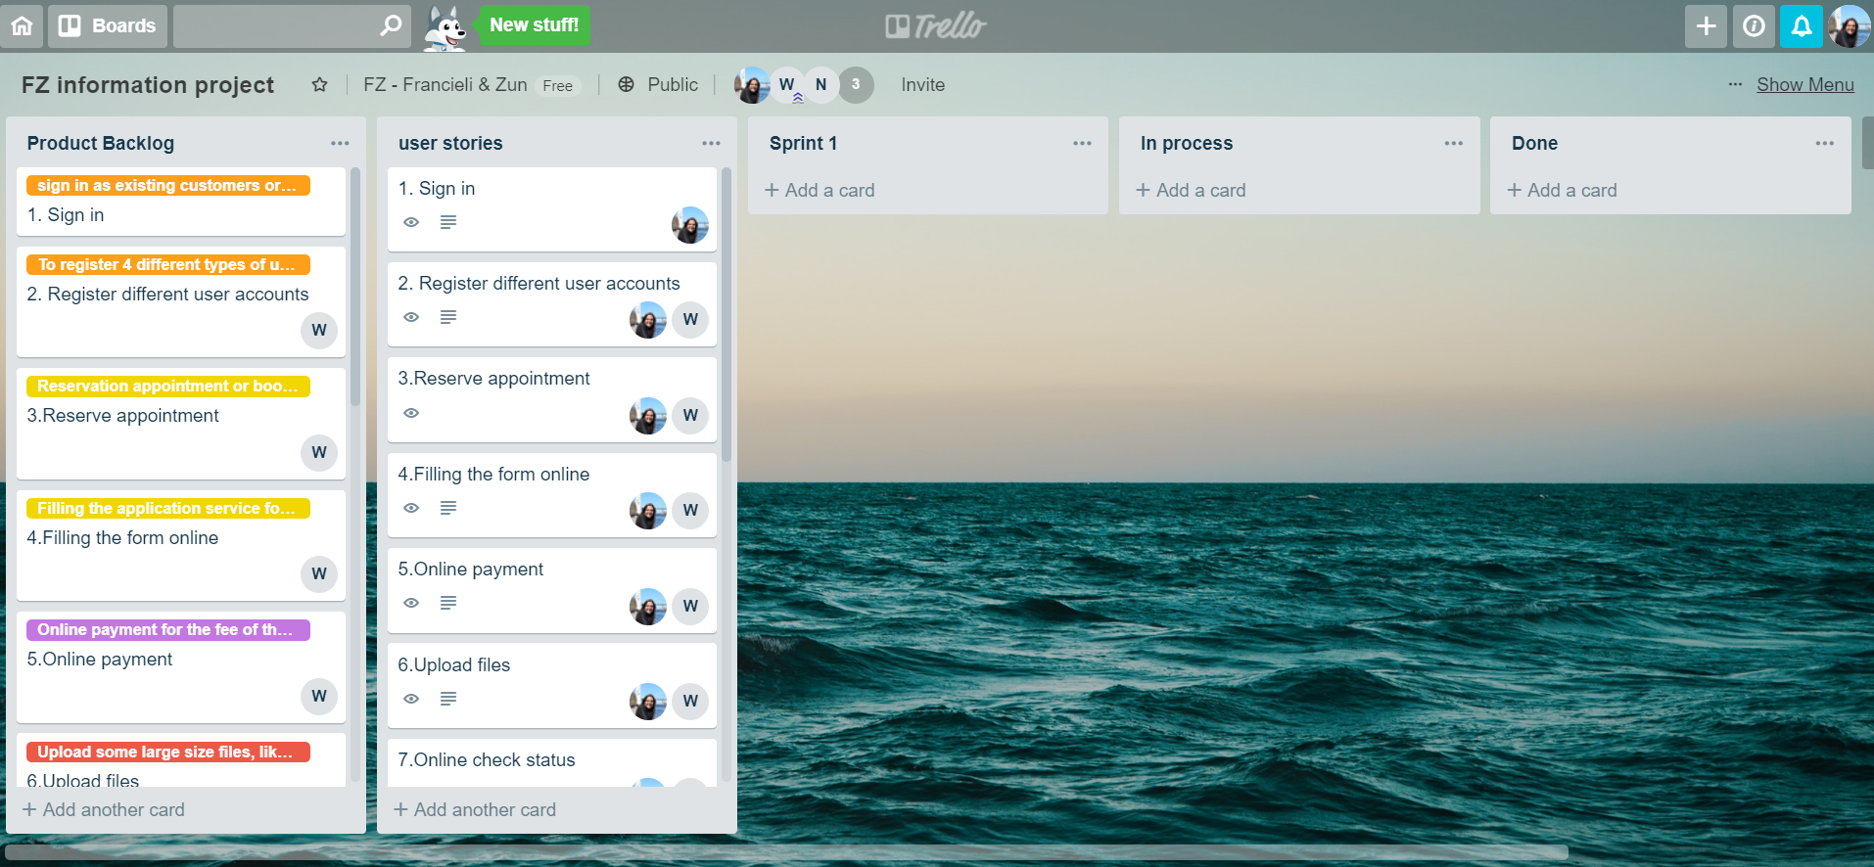

Picture 5 - Trello board content

With Trello board content, three major functions (that the system will perform) were selected to present in detail, like a use case analysis.

### First use case of analysis

|  |  |  |  |
| --- | --- | --- | --- |
| **Use case name:** Appointment reservation or service booking online | | **Id:** Functional Requirement 2 | |
| **Short description:** Customer who want to use the service can reserve appointment and book services. | | | |
| **Trigger:** When customer fill in and send applied form | | | |
| **Type:** External | | | |
| **Major Inputs** | | **Major Outputs** | |
| **Description** | **Source** | **Description** | **Destination** |
| 1. Customer general Information or login account  2. The booking service or reserving appointment information  3.building project or material testing documents information  4.Payment online information | 1. Customer input or login  2. Customer input or choose  3. Customer input and provide  4.Customer input | 1. verified of the customer’s general information put inside DB  2. verified of the login information to make sure it is correct  3. verified of the service customers selected and analysis the documents  4.verified of the payment information | 1. confirmation of the input information and acceptation  2.if login information is correct, let customer login  3. confirmation of accepted the customer application  4.confirmation of the payment and return the receipt |
| **Major steps performed** | | **Information for steps:** | |
| Step1. Customer login or create a new account and input their general information | | Customer provide their general information | |
| Step2. Customer select and book service, and the system display the details about the service | | Service information | |
| Step3. Customer fill in the apply form for use the service and send online | | Customer provide their project information for apply for use the service | |
| Step4.customer confirm the input online payment information | | Customer provide their bank information for paying online the fee of the service | |
| Step5.the web site system returns the confirmation about accepted the customer’s application | | Web site DB system provide the confirmation | |

### Second use case of analysis

|  |  |  |  |
| --- | --- | --- | --- |
| **Use case name:** payment online | | **Id:** Functional Requirement 4 | |
| **Short description:** customer pay the service fee online by bank card | | | |
| **Trigger:** when customer fill the form after book the service | | | |
| **Type:** temporal | | | |
| **Major Inputs** | | **Major Outputs** | |
| **Description** | **Source** | **Description** | **Source** |
| Bank card information | Customer input | Result of verified Card information | Card DB |
| The booking service information | Customer input | Confirm information and receipt | Bank DB |
| Customer Information | Customer input |  |  |
| **Major steps performed** | | **Information for steps:** | |
| Step1. customer book service and the system calculate the total amount | | Service information | |
| Step2. fill the form for apply for the payment online | | Customer information | |
| Step3. customer confirm the input bank card information | | Bank card information | |
| Step4. the system return the confirmation about the payment. | | Bank confirm information | |

### Third use case of analysis

|  |  |  |  |
| --- | --- | --- | --- |
| **Use case name:** Sign up or sign in account for customers | | **Id:** Functional Requirement 1 | |
| **Short description:** Customer who want to use the service can sign up and register, or sign if they had already an account. | | | |
| **Trigger:** When customer fill in sign up form or input their username or password | | | |
| **Type:** External | | | |
| **Major Inputs** | | **Major Outputs** | |
| **Description** | **Source** | **Description** | **Destination** |
| 1. Customer input their general Information for register  2. The current employees and customers input their username and password  3.after the customer login, show the information they can modify  4.show to the customer all the information they need  5.allow customers upload or download the files or other data or information | 1. Customer input online  2. Customer or employee  input their username and password, and answer the security questions  3. Customer choose or modify  4.system provide  5.customer upload or system provide | 1. verified of the customer’s general information put inside DB  2. verified of the login information to make sure if is correct  3. verified of the service customers selected and change the database  4.the system provide the data according to the customer  5.information into the system and data output to the customer | 1. confirmation of the input information and acceptation  2.if login information is correct, let customer login  3. confirmation of accepted the customer application  4.make system provide the right data  5.make the web visited speed fast and stable, provide upload and download choose |
| **Major steps performed** | | **Information for steps:** | |
| Step1.Customer create a new account and input their general information | | Customer provide their general information | |
| Step2. Customer fill in the apply form for register a new account | | Customer provide their general information | |
| Step3. Customer login their after they pass the security test | | Security verified | |
| Step4.show customer all the information after their login and let customer control or modify their account | | System provide customer service information or control menu for their requirement | |
| Step5.allowed customer to upload their documents or other information for their project or download the report or other documents | | Web site DB system provide the information or accept the upload data the customer provides | |

# ERD or Class diagram

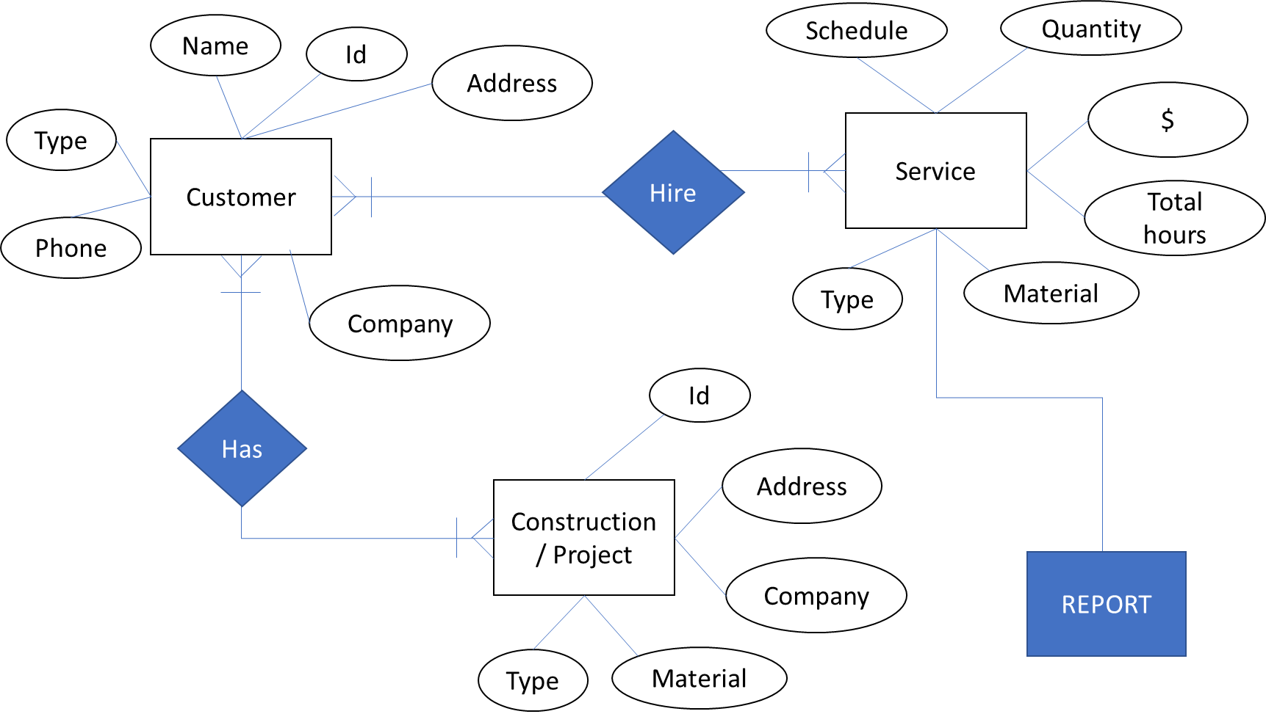

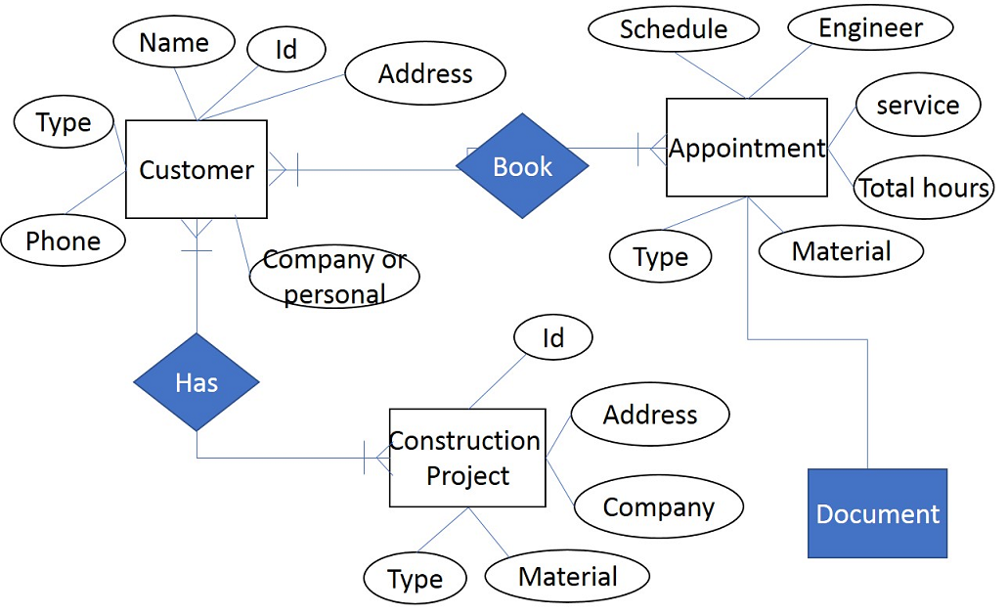

# UML diagrams: use case

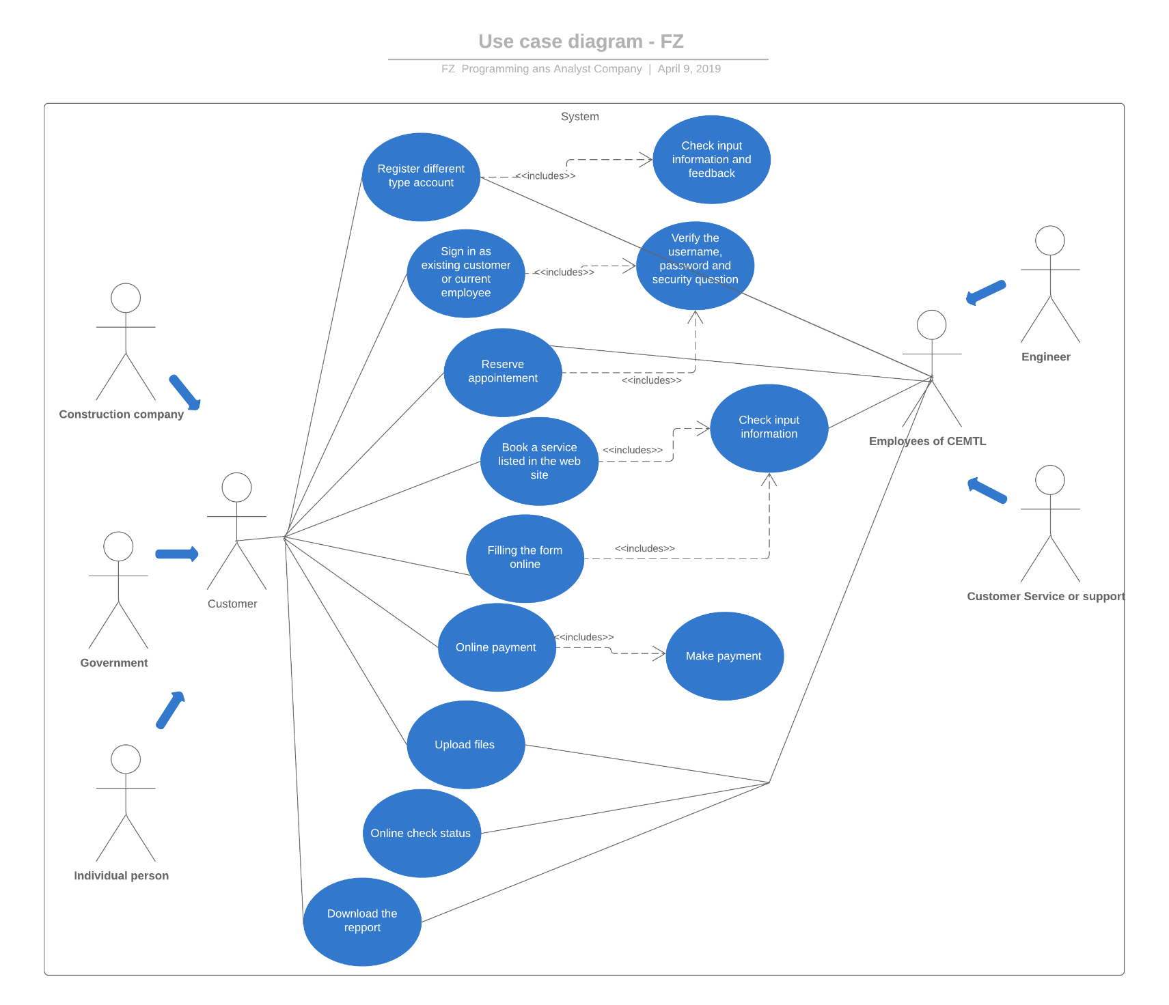

# Web Template Demonstration

Two mockup propositions were created. The first one was the preliminary version, presented in the first stage of the project. It is a navigable model, basically using HTML, CSS and JavaScript.

The second version is only a prototype developed with Adobe XD.

## First demonstration

**English version**

**First Mockup of project-English version.html**

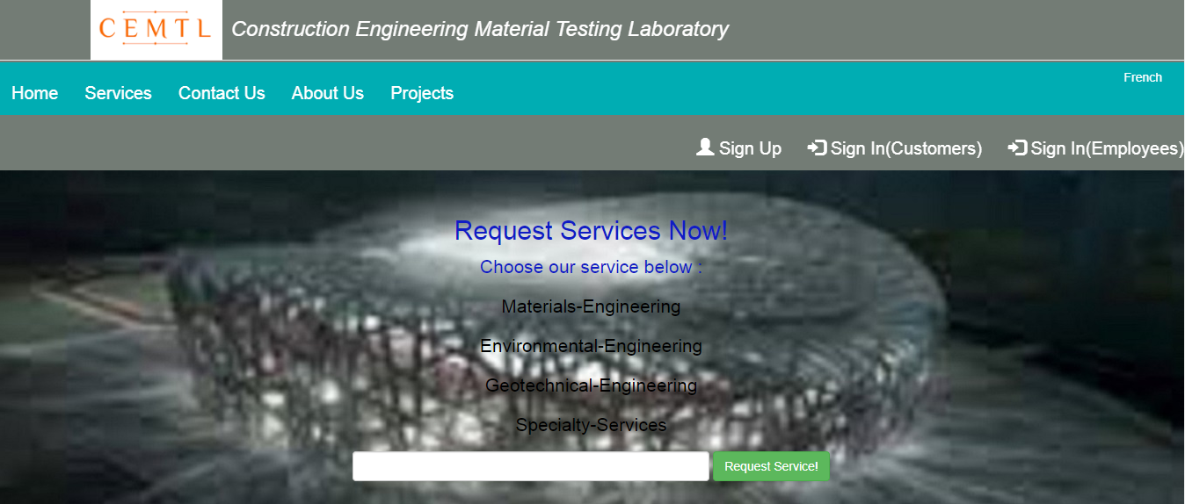





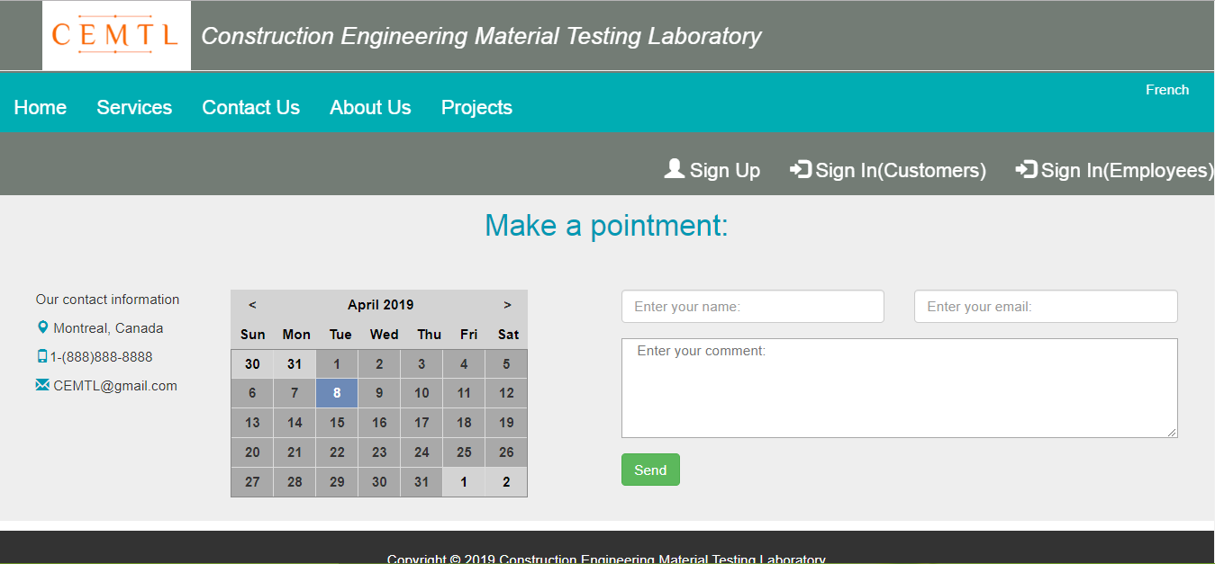

**First Mockup of project -French version.html**

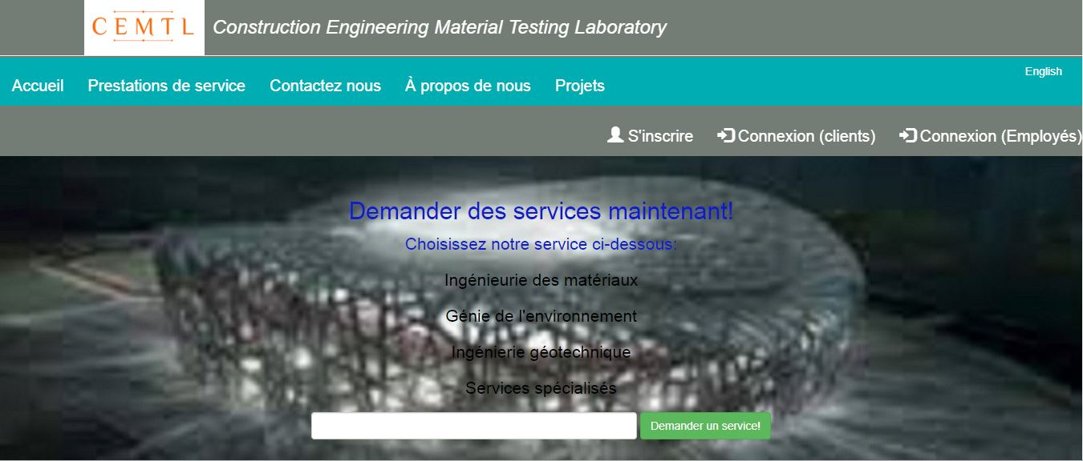



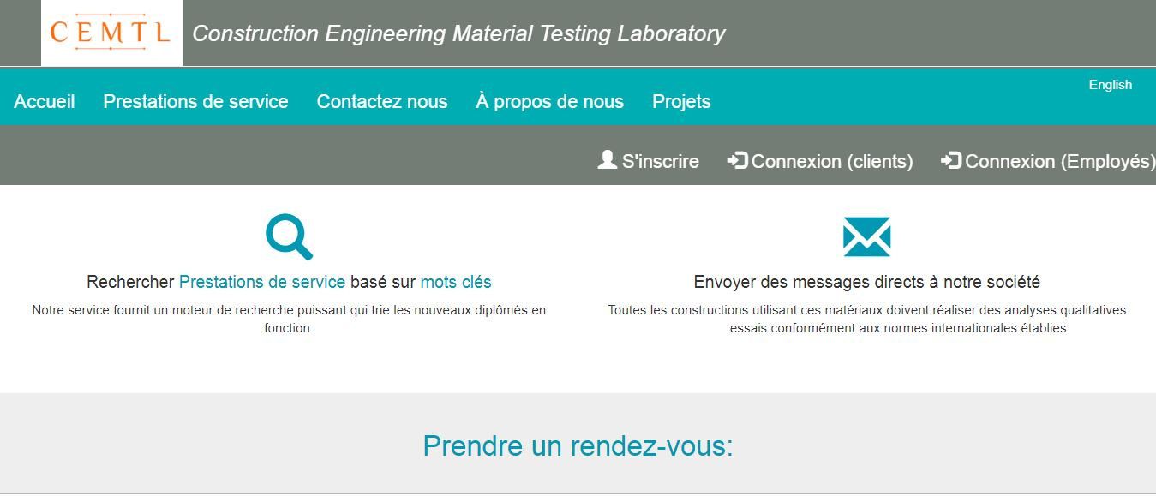

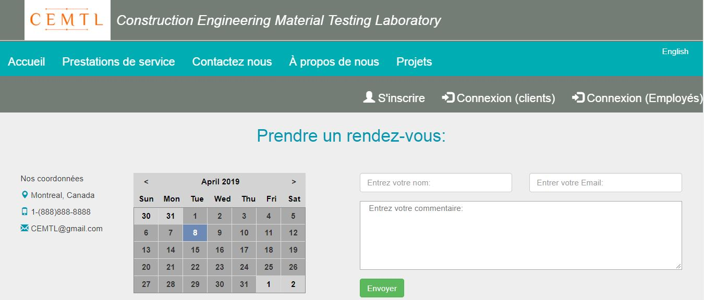

## Second demonstration

**English version**





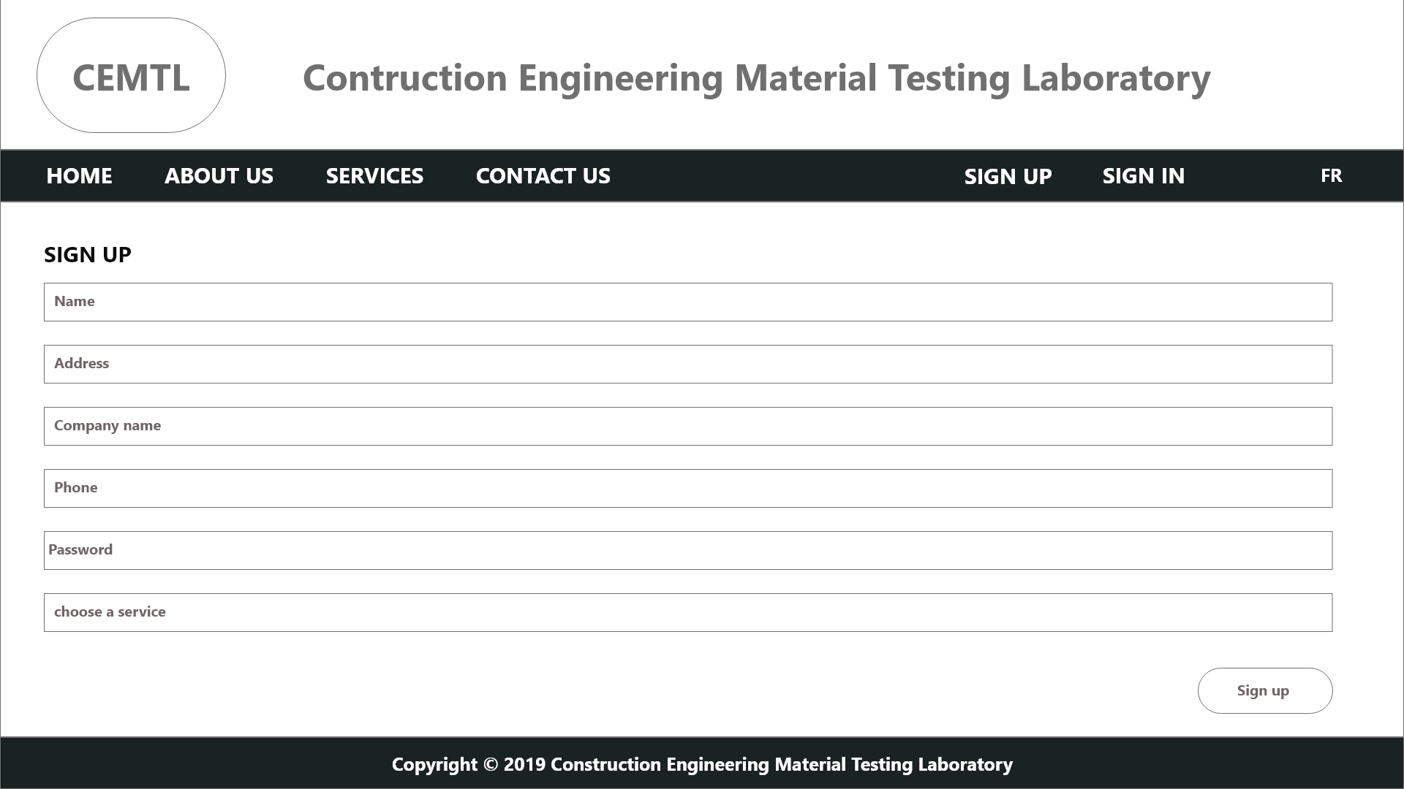

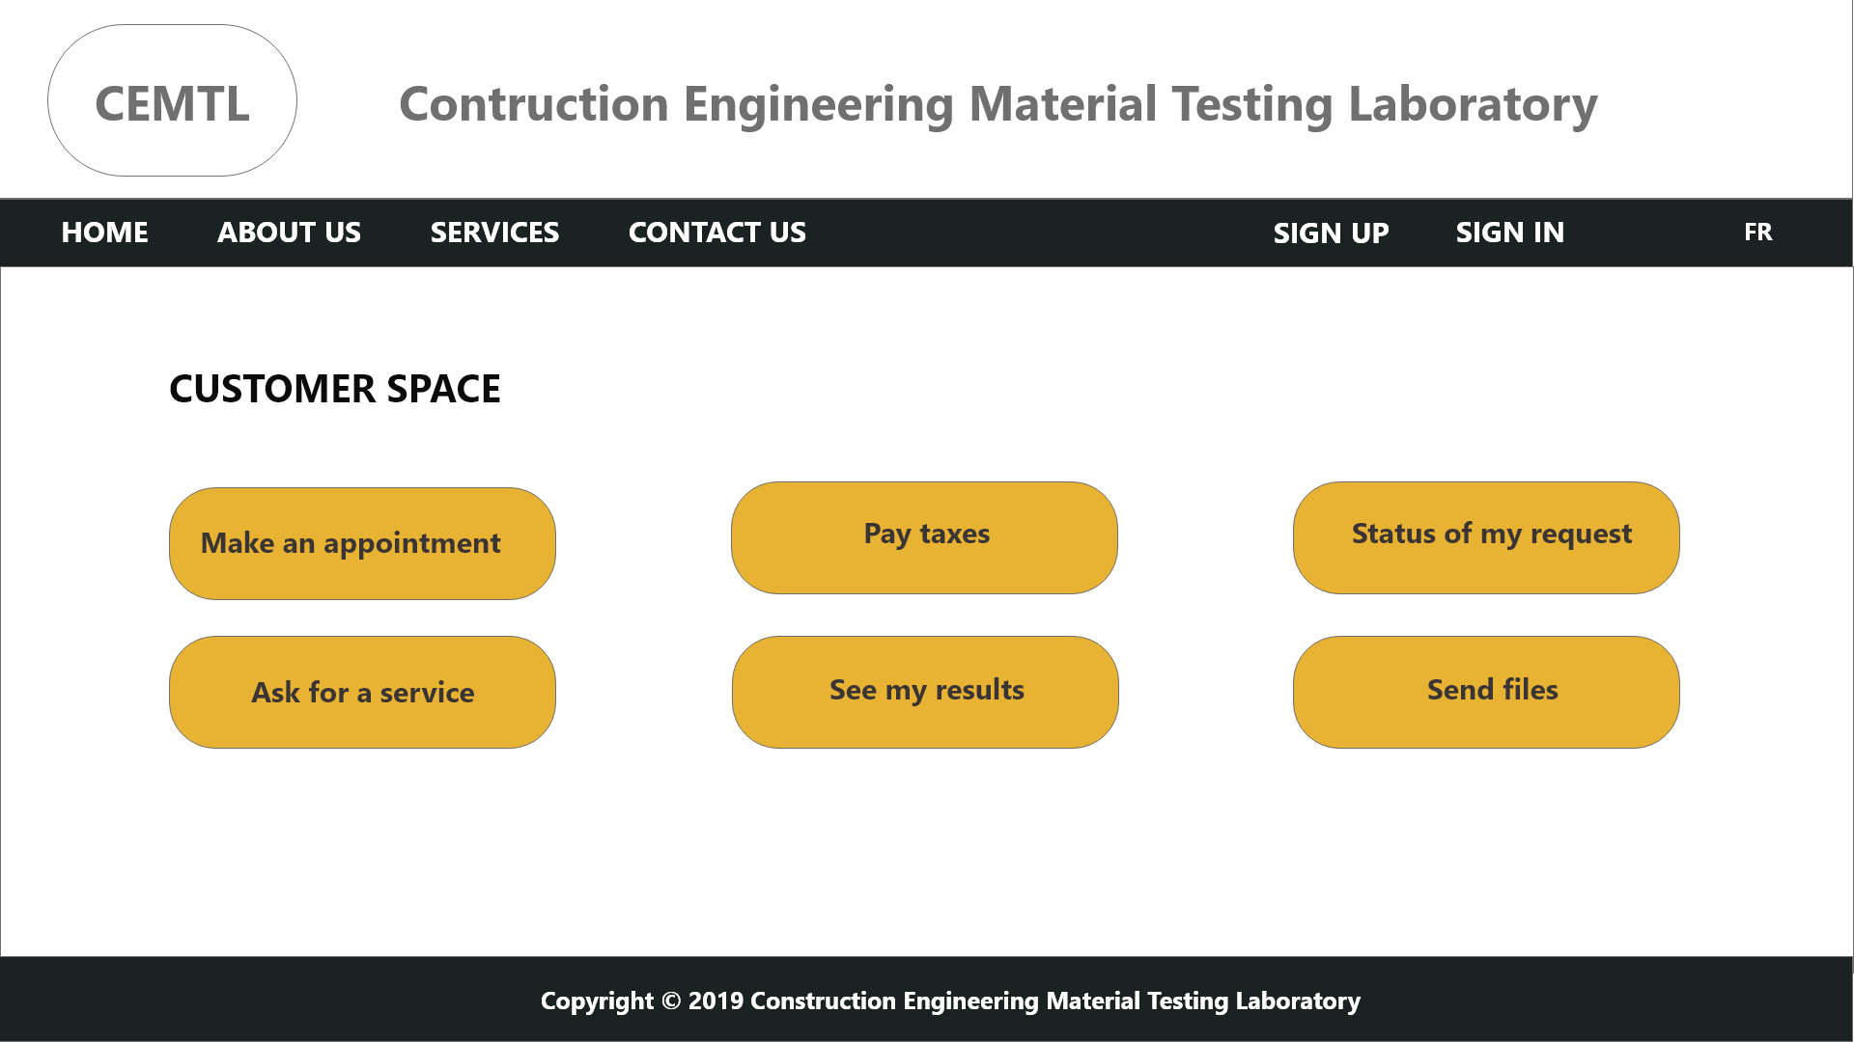

**French version**





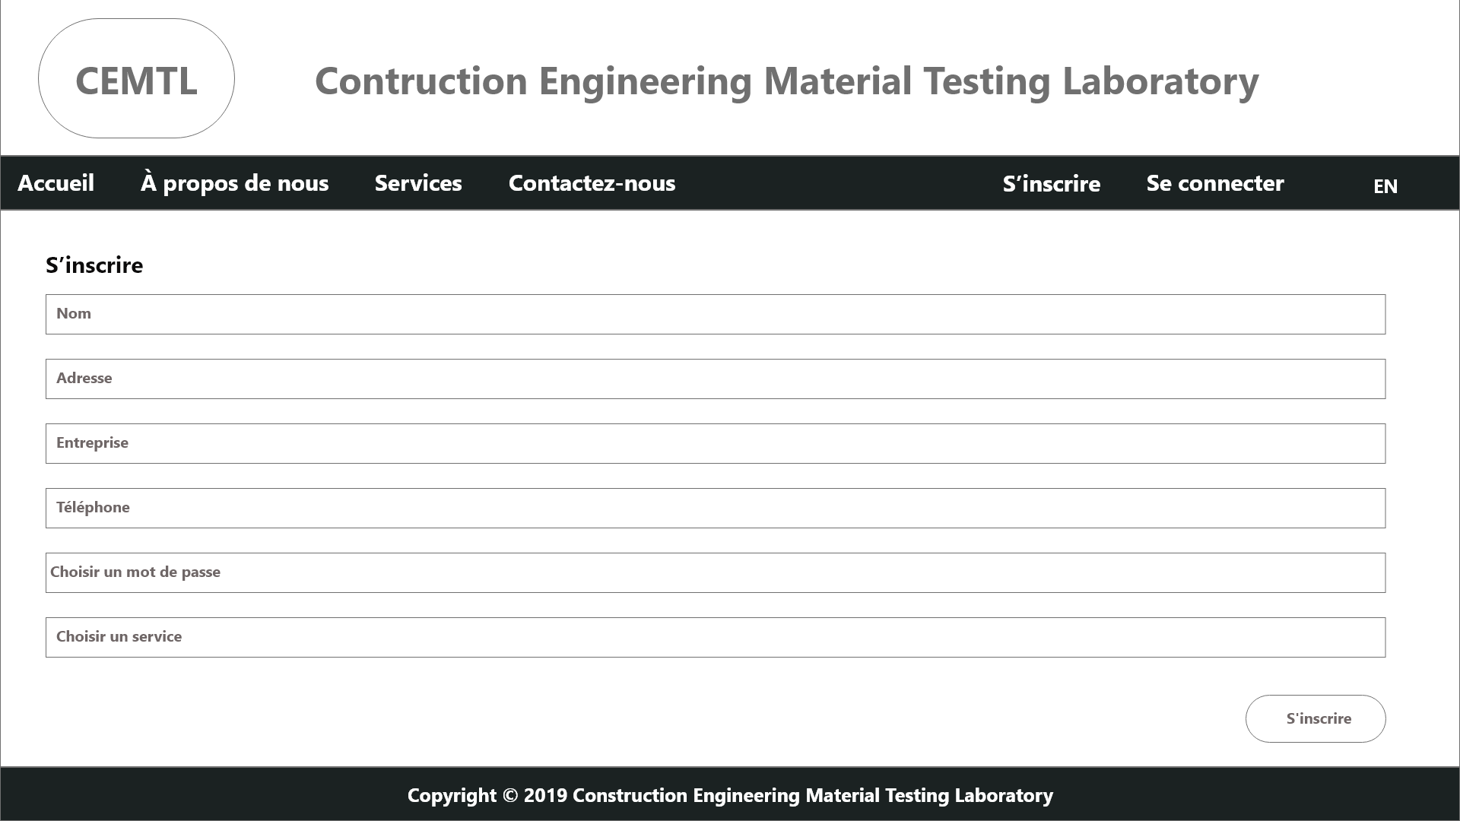

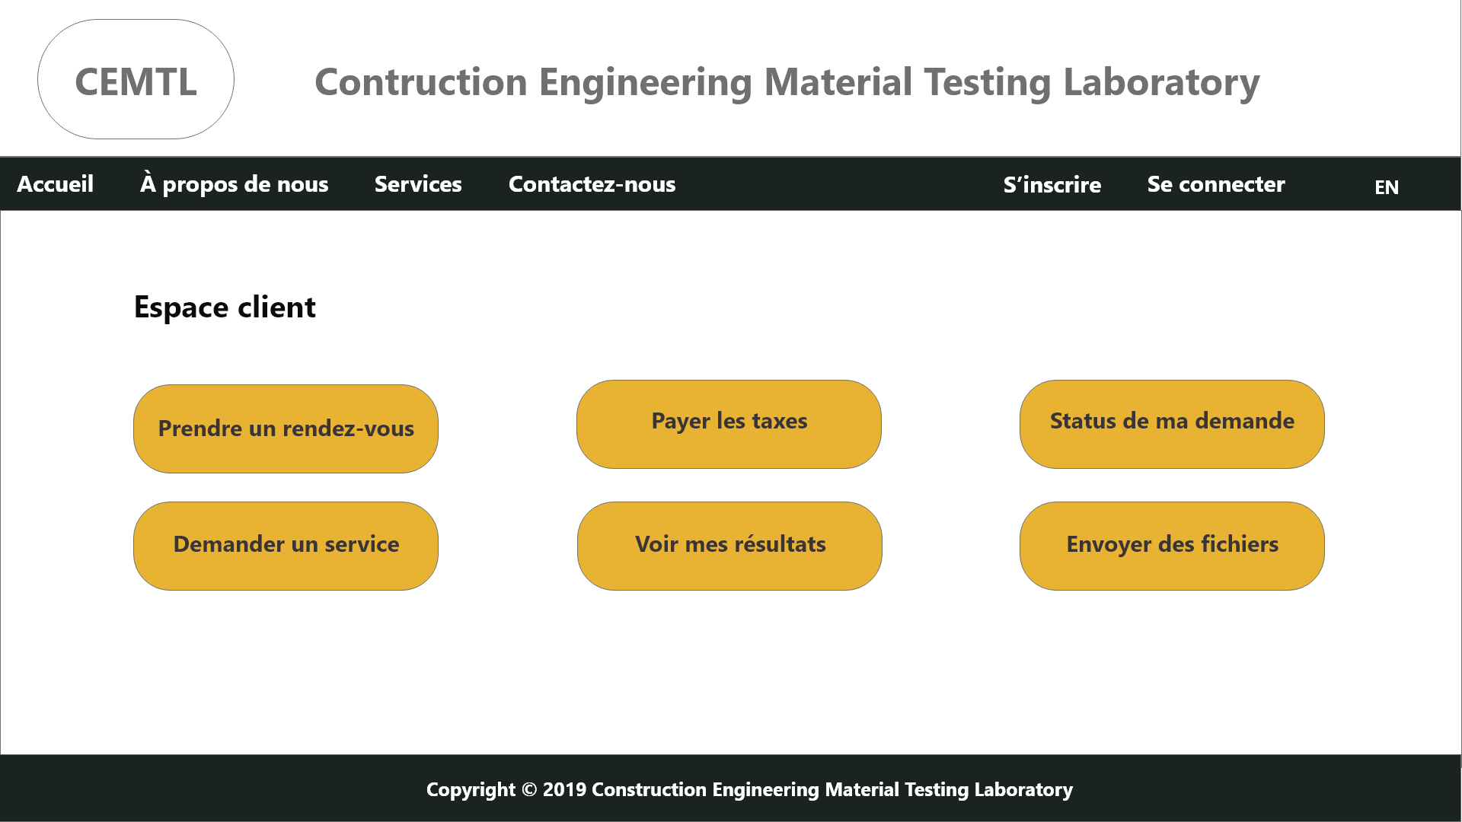

Online form – Request Services

